horizontal line

**Delhi Technological University**

Department of Applied Physics

IVth Semester

**MICROPROCESSORS & INTERFACING**

**MPI EP - 206**

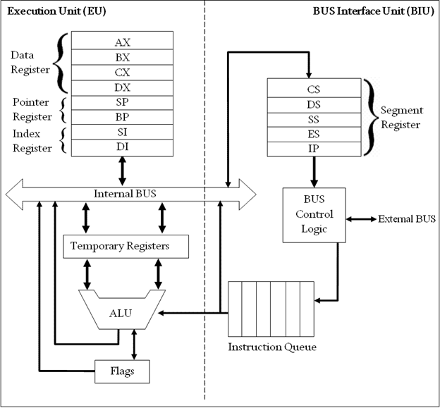

# **Submitted by :**

**ADITYA SINGH, 2K19/EP/005**

**Submitted to:**

**Dr. Rishu Chaujar**

# **Experiment 6**

**Generate an Geometric Progression (GP) Series**

**THEORY**

1. org 100h is used to set IP to 100h
2. Store 2000h memory location to the SI register
3. Store the value of the first term of GP in AL, common ratio in DL and number of terms in CX register.
4. Point SI to 2010h memory location.
5. Multiply the contents of AL and DL register and store it in AX register to get the next term of the series.
6. Display the terms by moving the contents of AX to the memory location pointed by the SI register.
7. Increment SI after every iteration to make it point to the next memory location.
8. Repeat steps 5-8 until CX=0

**CODE**

**org 100h**

**mov si, 2000h**

**mov al, [si]**

**mov dl, [si+1]**

**mov cx, [si+2]**

**mov si, 2010h**

**gp:**

**mov [si],al**

**mul dl**

**inc si**

**loop gp**

**hlt**

**OUTPUT**

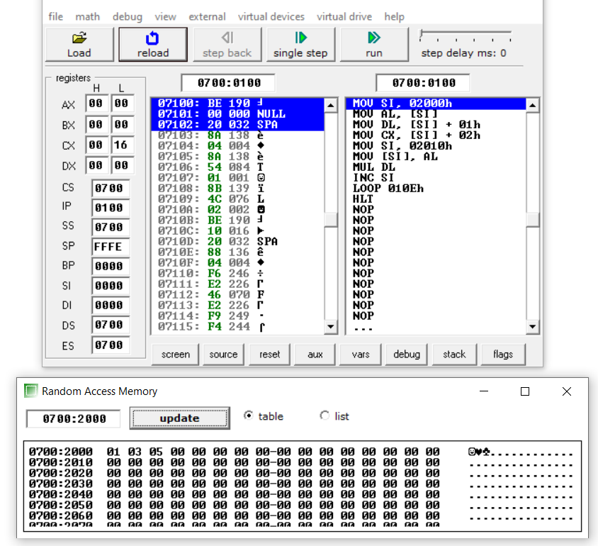

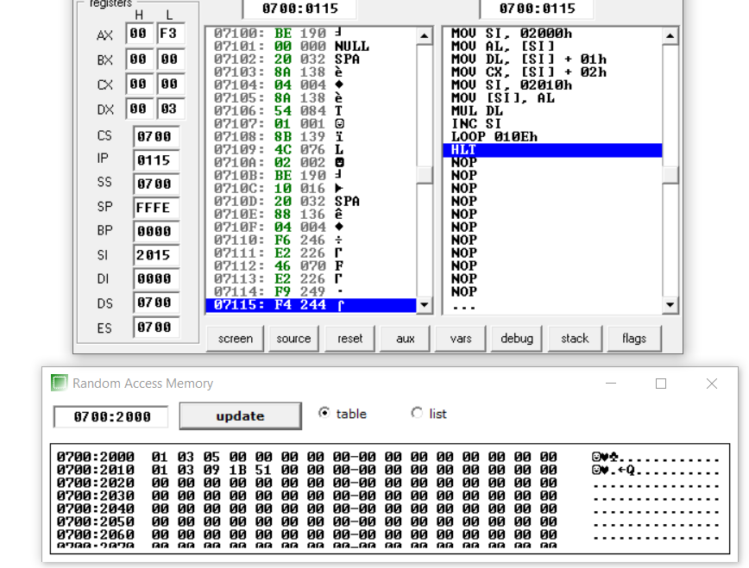

**END**